Enterprise Architecture – 4232

Lab sheet 02

1. **Create multithtreadapp**

package multithreadapp1;

public class MultiThreadApp1 {

public static void main(String[] args) {

}

}

**Create simplethread class**

package multithreadapp1;

public class SimpleThread extends Thread {

@Override

public void run() {

System.out.println(Thread.currentThread().getId() + " is executingthe thread.");

}

public static void main(String[] args) {

SimpleThread thread1 = new SimpleThread();

SimpleThread thread2 = new SimpleThread();

thread1.start(); // Starts thread1

thread2.start(); // Starts thread2

}}

Output

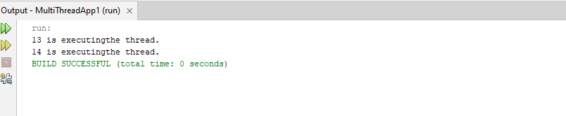

2.**create runnabletask class**

public class RunnableTask implements Runnable{

@Override

public void run() {

System.out.println(Thread.currentThread().getId() + " is executingthe runnable task.");

}

public static void main(String[] args) {

RunnableTask task1 = new RunnableTask();

RunnableTask task2 = new RunnableTask();

Thread thread1 = new Thread(task1);

Thread thread2 = new Thread(task2);

thread1.start(); // Starts thread1

thread2.start(); // Starts thread2

}

}

Output

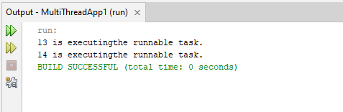

3.**counter class**

public class Counter {

private int count = 0;

// Synchronized method to ensure thread-safe access to the counter

public synchronized void increment() {

count++;

}

public int getCount() {

return count;

}}

**SynchronizedExample class**

**public class SynchronizedExample extends Thread{**

**private Counter counter;**

**public SynchronizedExample(Counter counter) {**

**this.counter = counter;**

**}**

**@Override**

**public void run() {**

**for (int i = 0; i < 1000; i++) {**

**counter.increment();**

**}**

**}**

**public static void main(String[] args) throws InterruptedException {**

**Counter counter = new Counter();**

**// Create and start multiple threads**

**Thread thread1 = new SynchronizedExample(counter);**

**Thread thread2 = new SynchronizedExample(counter);**

**thread1.start();**

**thread2.start();**

**// Wait for threads to finish**

**thread1.join();**

**thread2.join();**

**System.out.println("Final counter value: " + counter.getCount());**

**}}**

Output

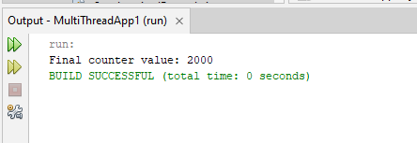

4. **create ThreadPoolExample.java. class**

import java.util.concurrent.ExecutorService;

import java.util.concurrent.Executors;

class Task implements Runnable {

private int taskId;

public Task(int taskId) {

this.taskId = taskId;

}

@Override

public void run() {

System.out.println("Task " + taskId + " is being processed by " +

Thread.currentThread().getName());

}}

public class ThreadPoolExample {

public static void main(String[] args) {

// Create a thread pool with 3 threads

ExecutorService executorService = Executors.newFixedThreadPool(3);

// Submit tasks to the pool

for (int i = 1; i <= 5; i++) {

executorService.submit(new Task(i));

}

// Shutdown the thread pool

executorService.shutdown();

}}

Output

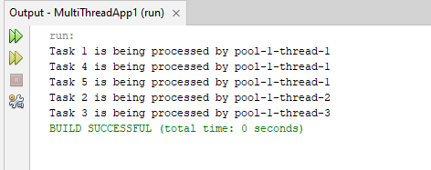

**5.Create ThreadLifecycleExample class**

public class ThreadLifecycleExample extends Thread{

@Override

public void run() {

System.out.println(Thread.currentThread().getName() + " - State: " +

Thread.currentThread().getState());

try {

Thread.sleep(2000); // Simulate waiting state

} catch (InterruptedException e) {

e.printStackTrace();}

System.out.println(Thread.currentThread().getName() + " - State aftersleep: " + Thread.currentThread().getState());}

public static void main(String[] args) {

ThreadLifecycleExample thread = new ThreadLifecycleExample();

System.out.println(thread.getName() + " - State before start: " +

thread.getState());

thread.start(); // Start the thread

System.out.println(thread.getName() + " - State after start: " +

thread.getState());

}}

**Output**

